**TITLE OF THE STUDY PRESENTED IN THE ABSTRACT**

(Title of the extended abstract should be the same as that of the abstract submitted. The title should appear in the correct style (All Caps, 12pt., Times New Roman, left-justified).)

**INTRODUCTION** (All Caps, 12pt., Times New Roman, left-justified)

The introduction should provide a concise overview of the research context, clearly define the problem or research question, and explain the significance of the study. It should also outline the main objectives and contributions of the research, providing a brief statement of the methods used.

**METHODOLOGY** (All Caps, 12pt., Times New Roman, left-justified)

The methodology should briefly outline the research design, methods, and procedures used to achieve the study's objectives. Authors should provide a clear description of the approach, including the type of research (e.g., experimental, survey, qualitative, quantitative), data collection methods, tools, and techniques employed. Emphasize any novel or unique aspects of the methodology and justify why the chosen methods are suitable for addressing the research problem. This section should be concise but sufficiently detailed to allow the reader to understand how the research was conducted.

**RESULTS AND DISCUSSION** (All Caps, 12pt., Times New Roman, left-justified)

This section should succinctly present the key findings of the research, highlighting the most important data or results relevant to the study's objectives. Authors should interpret the results, discussing their implications, significance, and relevance to the research problem. Compare findings with previous studies, explain any unexpected outcomes, and provide insights into the broader impact of the research. **Note that the results and discussion should amount to 50% of the extended abstract.**

**CONCLUSION(S)** (All Caps, 12pt., Times New Roman, left-justified)

The conclusion should provide a concise summary of the main findings and their significance in the context of the research problem. Authors should highlight the key contributions of their study, its potential impact, and any practical applications or theoretical implications. Briefly mention any limitations of the study and suggest directions for future research. Keep this section focused and to the point, emphasizing the main takeaways for the reader.

**REFERENCES** (All Caps, 12pt., Times New Roman, left-justified)

Include **maximum 05** essential references cited in the abstract. Format all references according to [IEEE style](http://journals.ieeeauthorcenter.ieee.org/wp-content/uploads/sites/7/IEEE_Reference_Guide.pdf). Ensure consistency between in-text citations and the reference list, and provide complete bibliographic details for each source.

**Extended Abstract Preparation - Specific Guidelines**

1. Extended abstract (**Word limit 1800; maximum four (04) pages**; page numbers should be included)
2. **Remove names** of authors and their affiliations for the purpose of double-blinded reviewing.
3. All abstracts should be written in English language using MS Word (.docx/.doc format) or appropriate tool/software. You must submit a **Word Format** of your abstract for review.

Use the following levels of this font type to describe the different sections of your extended abstract;

1. Heading 1: 12-POINT TIMES NEW ROMAN, BOLD, ALL CAPS
2. Heading 2: 11-Point Times New Roman, Bold
3. Heading 3: 11-Point Times New Roman, Bold
4. Normal (body) text: 11-point Times New Roman, Justified
5. Paper Size: A4
6. Margins: 1 inch for left, right, top and bottom
7. Line spacing: Single, One column of text
8. Figures: See the following content for more information (a maximum of 2 figures)
9. Tables: See the following content for more information (a maximum of 2 tables)

## **Figures and Tables:**

#### **Positioning Figures and Tables:** Figure captions should be below the figures; table heads should appear above the tables. Insert figures and tables near to they are cited in the text. Use the abbreviation “Fig. 1”, even at the beginning of a sentence. Table numbers should be indicated in the text as (Table I) if it is a part of a sentence.

**Figure and table labels:** Use 10 point Times New Roman for Figure and table labels. Use words rather than symbols or abbreviations when writing Figure axis labels to avoid confusing the reader.

Table I. Name of the table (Title caption)

| Table Head | Table Column Head | | |
| --- | --- | --- | --- |
| Table column subhead | Subhead | Subhead |
| Example | More example |  |  |

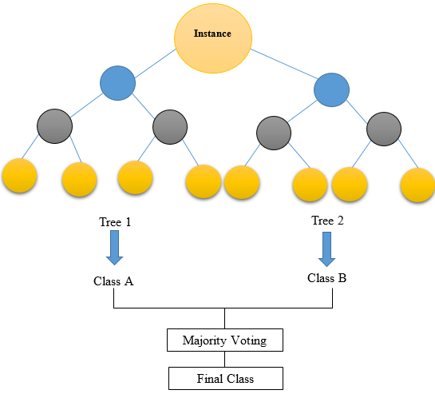

1. Example of a figure caption (figure caption)